TOT Material Management`

Day 04

Monitor Purchase Requestion

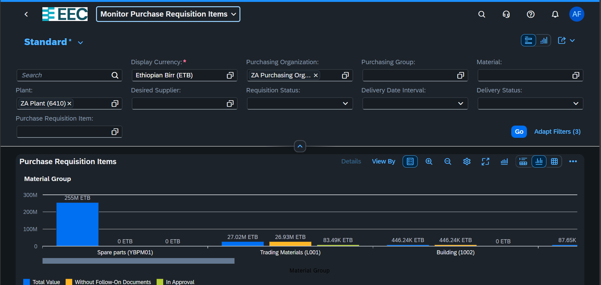

After PR Created Approval Proceed

Selected Groups under go for Approval

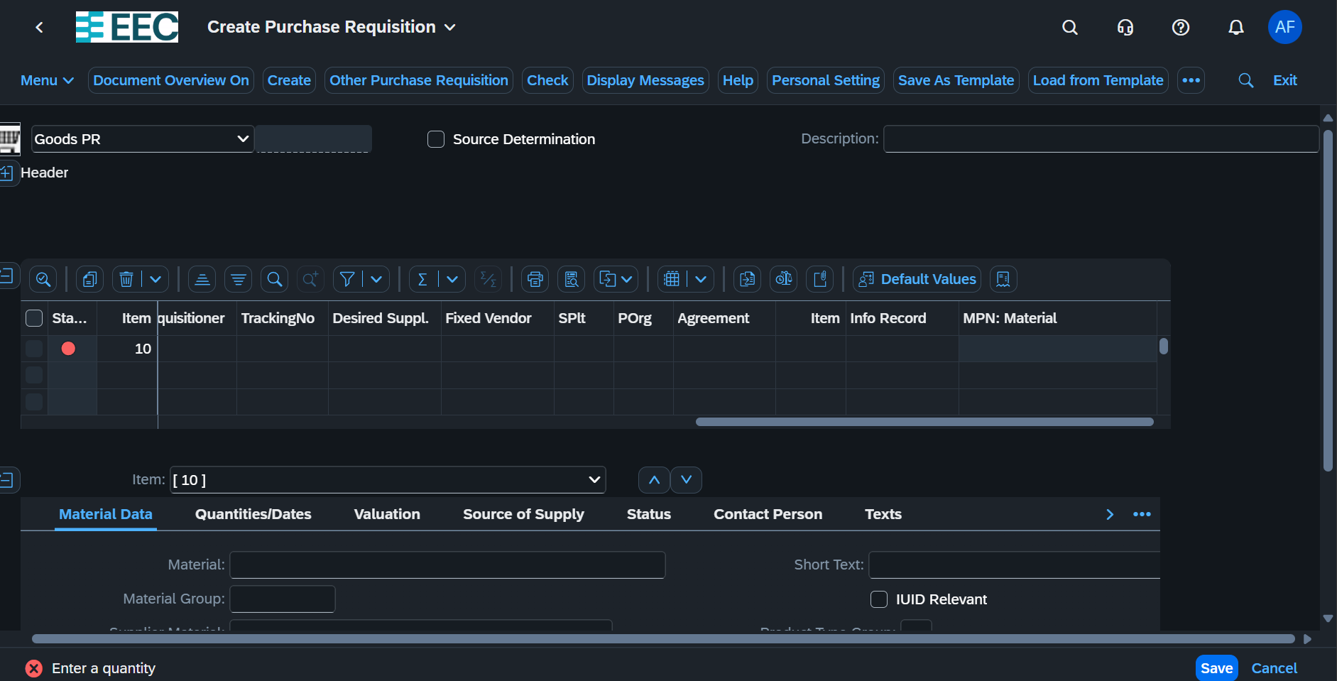

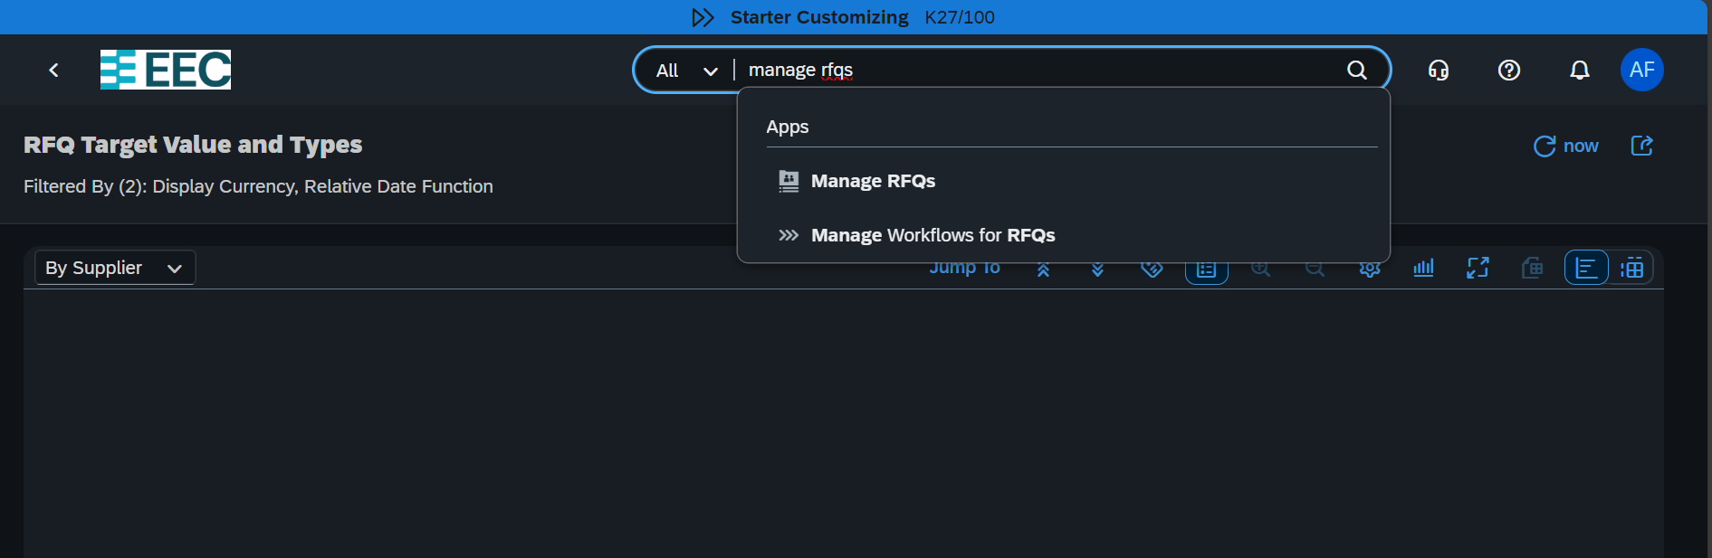

Then Click Create Button

Fill The Necessary Fields

After requesting the PR it awaits the Approval of PR Group

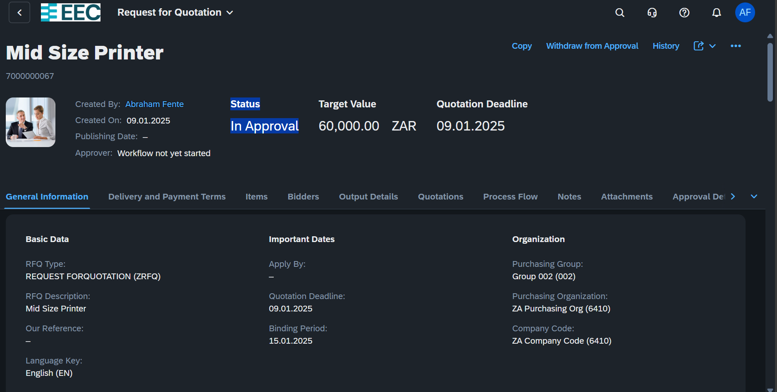

Create Purchase Contract

**Day 6: 1/13/2025**

Creating Purchase Order

Then prepare GRN for The Purchase Product

Upon The Purchase Order Completed and the GRN May be Canceled in this case we need to prepare outgoing Purchase Order.

After GRN we Need to Create Invoice

**Create PO From Quotations**

*Go to Manage Supplier Quotation*

*Filter list of lets filter by Created BY*

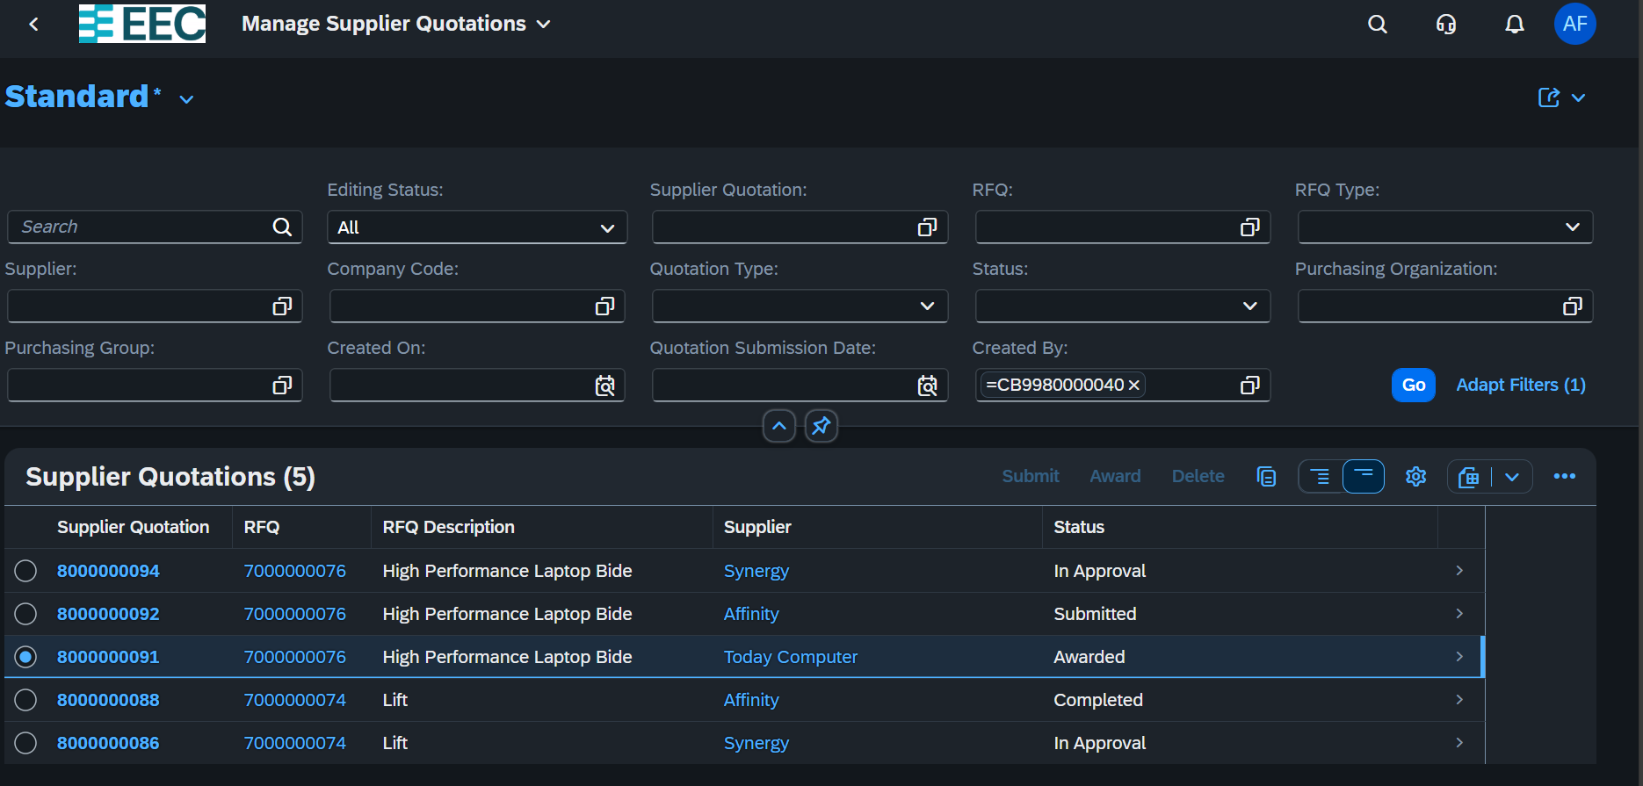

Then select the Awarded one and click on Follow Document

To create a GRN type migo

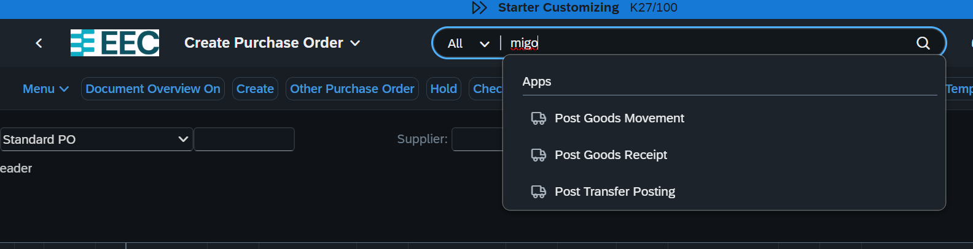

**DAY 07: 1/14/2025**

Approval of Purchasing order

After approval we need to Manage entry sheet

App name *Manage service entry sheet*

*General Steps*

*Create PO ->Approve PO->Create Service Entry Sheet->Approve->Create an Invoice*

STO without billing

Sub-Contracting

When we prepare PO we need to write necessary and common prices in the header section as condition.

**Day 08 1/17/2025**

Create Pl Document

Count

Post

Then mange the physical inventory

How to Remove Expired items from the Stock (Scraping)?

Same step with Posting goods like this

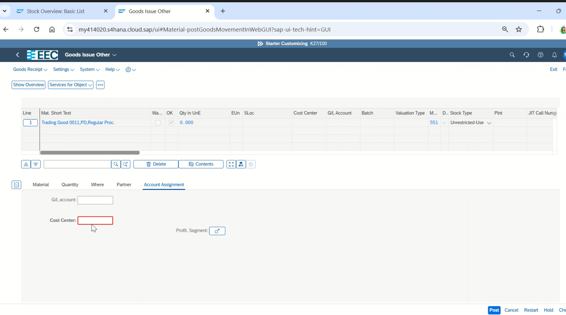

**Scenario For External procurement**

Create material

then